
Uranquinty Public School Newsletter

Email: uranquinty-p.school@det.nsw.edu.au

Phone: 6922 9619 Fax: 6922 9883
Website: www.uranquinty-p.schools.nsw.edu.au Term 1 Week 2 2015

Welcome Kinders
We are so pleased to welcome each of our new Kinder students and their families to our school. I trust each family will feel quickly accepted into our school community as we work and learn together to provide excellence in education, here in Uranquinty.

School Directions
Our new school plan for 2015-2017 will be available soon on our school website. It is built around three strategic directions, which are; Lifelong Learning, Building Wellbeing and Community Connections. I will be explaining more about our directions as we head into the year and how you can be involved in moving our school forward.

School Values
The new school plan incorporates our School Values which are Respect, Safety and Learning. These are the values from which our school and classroom expectations are formed. The new student welfare policy which was given to all families at the end of last year, will be forwarded to all new families next week. This policy has now been adopted and will be issued with the only change being the name – the policy will now be called Student Wellbeing Policy to align with our new school plan.

Assembly
The School, Vice and House Captains will receive their badges at our first assembly tomorrow at 3pm. The SRC representatives will also be announced. I invite all families to attend this special occasion.

General Permission Notes
Please read, sign and return the attached permission notes which will remain current all year unless you inform us of any changes.
Staffing
I have much pleasure in announcing our 2015 staff members and their roles, please introduce yourself to our new staff members and make them welcome.

K/1 – Mrs Forrell
2/3 – Mrs Crick
4/5/6 – Miss Fuller
Library – Mrs Brett (Tuesdays)
Release – Mr Robinson (Thurs/Fri)
Support – Ms Fahey (Wed/Thurs)

Admin Manager – Ms Caskie
Admin Support – Mrs Logan (Tues)
General Assistant – Mr Blight (Tue/Thur)
Cleaner – Mrs Lucas

Classroom Meetings
Parents are welcome to attend classroom meetings this week to find out a little more about classroom routines and ask general questions of the teachers. We have put the meetings at different times so that parents of siblings can get to each one if desired. If these times don’t suit, feel free to find a time to chat to your child’s teacher that is mutually agreeable.
K/1 – Thursday 9:30am
4/5/6 – Thursday 3:00pm
2/3 – Friday 3:00pm

Swimming Carnivals
We are having our Uranquinty PS swimming carnival on Friday 13th Feb. All students (K-6) will be attending this carnival and families are most welcome to attend this carnival at The Rock Memorial Pool commencing at 10am. Parents are responsible to transport their own children or arrange transport with another family. If any parent is having difficulty with the transport, please let me know so we can assist. Children are welcome to come in their house colours;
- Kookaburras/yellow
- Rosellas/blue.

The Wagga Small Schools Swimming Carnival will be held on Monday 16th Feb at the Oasis Pool in Wagga. This carnival will be for the 2/3 & 4/5/6 students only. Parents will need to transport or car pool for this carnival as well. The first race commences at 10am so please be there before this time.

Supervision Before School
Please note that staff are on duty in the playground from 9am. If your child needs to be at school earlier than that for a specific reason, they must go to the library where I will supervise them.

Sheffield Shield Match
Our Yr 2-6 students will have the opportunity to watch a Sheffield Shield match in Wagga in Week 4. Students interested in watching the match will receive a permission note next week and the cost will simply cover the bus fare.

Professional Learning - TOWN
I will be attending a training course in Sydney next week for three days. The course is called TOWN –Taking Off With Numeracy. I will then be training staff from across the community of small schools throughout the year. Mr Robinson will replace me on 2/3 during these days and Mrs Forrell will relieve in the Principal role.

Cathy Crick
Pricipal

Canteen News
Dear Parents,
Welcome to 2015 and I look forward to working with you in the canteen throughout the year.
This year due to personal study load, canteen will run every Friday as normal and Monday's will go back to chicken burgers once a fortnight.
Through the year I will be trying different items on Friday’s menu. Please find attached volunteer sheet if you can help out even just one shift it would be fantastic.
Price list will soon follow once I have done the canteen roster for the term.
Thankyou
Teresa McDonald
Canteen Manager

Welcome to Wagga Wagga
Event: Welcome to Wagga Wagga – for new residents to the City
Date: Wednesday 1 April 2015
Time: 6pm – 7.30pm
Venue: Wagga Wagga Art Gallery
Dress: Smart casual
RSVP: Donna business@wagga.nsw.gov.au



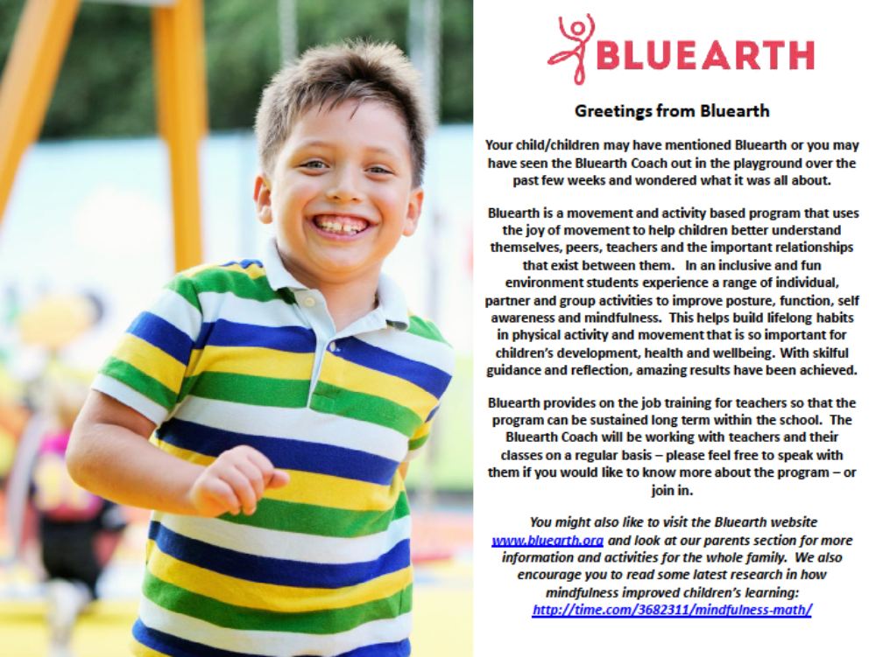----------------------------------------------------------------------------------------------------------------------------------

SCHOOL CANTEEN VOLUNTEER FOR TERM 1 2015

The school canteen operates every Friday for children to order their lunch.
Two parent volunteers are required to be at school at 9.00am on Friday morning to take lunch orders.
Two further parent volunteers come back to school at 12.30pm to prepare the lunch orders and to serve the children at lunch time.

-----------------------------------------------------Please cut along line------------------------------------------------

I am willing to volunteer for canteen duty in term 1:

NAME:__________________________________________________

PHONE:_________________________________________________

I am available:

1 per term ​​ 2 per term​​​ 3 per term

Morning ​​​ Lunch ​​​​Either

Please return by Friday 6th February 2015

Thankyou
Teresa McDonald
Canteen Manager


